Literacy ideas

Lesson ideas linked to Nurdle
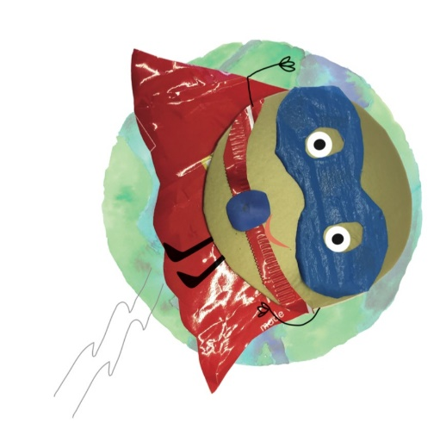

Read and Comprehend

Read the story of Nurdle with the class/your child.
- Why is Nurdle sad?
- Why has Nurdle been put in jail?
- How many ways can nurdles escape?
- How do nurdles end up in the sea?
- Can I pick up a nurdle I find on the beach?
- Why do the birds and animals eat nurdles?
- What are good and positive examples of plastics that Nurdles would want to become? (medicine is a good example)
- What are single use plastics?
- What are the 3 R’s we can do to help Nurdle and his friends?
- Why are nurdles used to make plastics?

Design a poster
- No more single use
- Reduce, Reuse, Recycle
- Single use plastic is not fantastic
- Do not drop litter

Get children to talk about the central themes from the story and the important messages. Choose one and use it to design posters for the school or town.

Write your own Nurdle story

Choose one of the Nurdle characters and write the journey of them from the factory to the ocean. What happens to them? Do they get eaten? Do they end up in a river or waterfall? Do they get saved and sent to landfill or become a work of art? Maybe they don’t end up in the sea and become part of something great!

Letter writing

Write a letter to your local plastic manufacturing plant asking how they keep nurdles safe.
Or write a letter to your MP asking for single use plastics to be banned.
Write a letter to companies that make single use plastic products explaining the problems that are caused.

Poetry - Write your own NURDLE acrostic poem

Nurdles just want to make things that are useful
Under the water is not the place for a Nurdle!
Round as a lentil, nurdles are really tiny,
Down a throat they float, mistaken for food.
Lots of nurdles escape into the sea every year.
Everyone can help by using less plastic!

Debate:
Have a class debate.
Half of the class argue that nurdles are the problem and should be banned.
Half the class argue that nurdles are useful, they just need to be looked after properly and not allowed to get into the sea.
Which side wins, or was it too close to call?

Animal Fact Files

Investigate the animals that live in the sea, how many of the are affected by ocean plastic? Create fact files on ocean animals. There are great resources to help this on the Fidra website.
Maybe focus on some sea animals which are in danger of becoming extinct.

Engineering ideas

My class engineered solutions to nurdle related problems. We entered their solutions into a national engineering competition, but there is also the little inventors website.
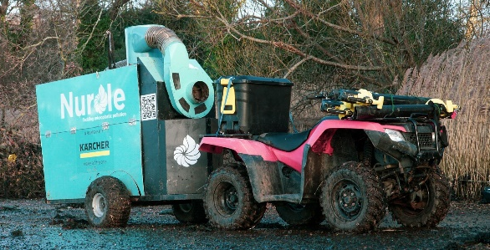
www.littleinventors.org

How to remove nurdles from a sandy beach?
How to remove nurdles from the sea?
How to stop nurdles escaping from storm drains?
How to collect nurdles from sandy or shingle beaches?
How to encourage people to not use single use products.

My class designed:
- A remote control nurdle car that sucked nurdles from storm drains
- A nurdle drone that collected nurdles from the sea with a scoop but also helped animal who had ingested nurdles.
- Nurdle static balloon on a stick etc

https://nurdle.org.uk/ has examples of two amazing nurdle removing engineering solutions.

Maths ideas

If you live near a beach go on a nurdle hunt and record your results with the Great Nurdler. www.nurdlehunt
How many nurdles can you find in a square metre of beach. How many does that mean could be on the whole beach?

Measure:
A microplastic is anything smaller than 5mm in diameter. Measure the things you have collected from the beach. How many nurdles/micro-plastics do you have?

Graphs:
Create bar charts or pie charts to show the rubbish that you have collected form the beach or from a local litter pick. Can you sort the rubbish into different categories?

Volume
Weigh an object and calculate how many nurdles it would take to make that object.
100g contains roughly 4000 nurdles.

Safety: If you go on a nurdle hunt collect the nurdles in a sealed box or jar if you want to keep them, or seal in a bag to dispose safely. Wear gloves, and wash your hands thoroughly.

Science ideas

A micro-plastic is anything smaller than 5mm. Nurdles are primary micro-plastics as they enter the ocean already as a micro-plastic.
Secondary micro-plastics are still smaller than 5mm but have often broken down from something bigger.

Go on a nurdle hunt
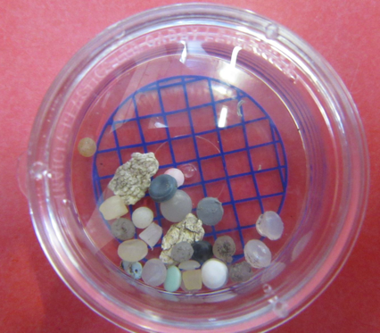
Can you sort the things that you have collected into primary and secondary micro-plastics? Can you always tell?
Which float and which sink?
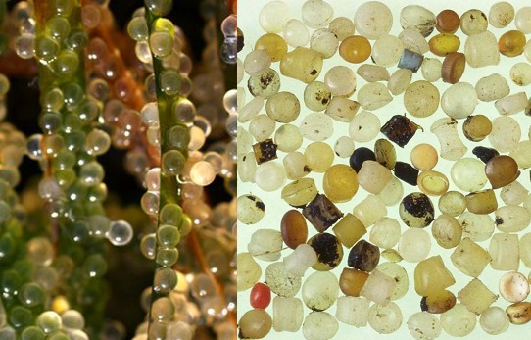
What can be recycled?

Food chains

Nurdles are eaten by animals mistaking them for food.
Nurdles look a lot like fish eggs.
Investigate which animals are likely to try to eat nurdles.
Nurdles and fish eggs
Everything leads to the ocean
Look at the water cycle and learn how a nurdle dropped in a river can end up in the sea.

Art ideas

Recycled Artwork
Use the templates to create your own fabulous artwork from ocean plastic, household waste or micro plastics. Remember to wash things first.

- Plastic bottle Jellyfish

- Mandala decorated Nurdle collecting jars.

- Ocean plastic collage

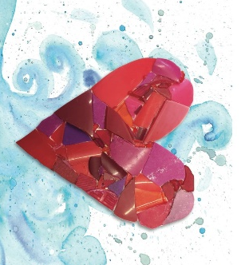
- Underwater watercolours and mixed media artwork. Create a giant class underwater collage and use it as the background to show off all of the fabulous artwork that you have created.

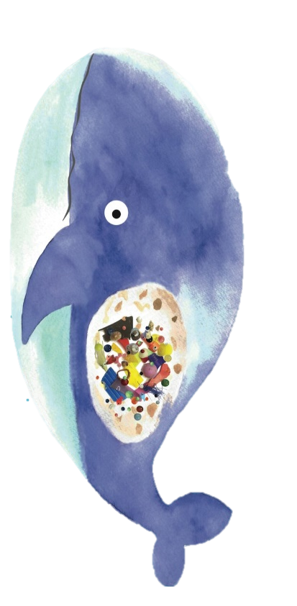
Music ideas

Create your own musical instruments from recycled products and use them to create your own underwater melodies.

- Wrapping paper roll rain stick
- Yoghurt pot shakers
- Balloon drum

Environmental ideas

There are 4 main polluters of our environment and oceans:
- Plastic straws
- Single use water bottles
Tea and coffee cups

- Plastic bags

See if you can find ways to get these things removed from your school. Make a pledge to remove one of the big 4 from your home. Think of things that you could replace them with.

Hold elections for Environment Managers for your school.
Make them write a speech for what they would do to help their environment.
In my school children:
Turn off the lights
Empty the recycling bins every week
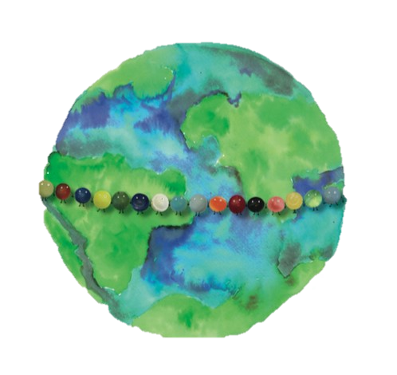
Collect all of the teabags from the staff room
Collect in the food waste bins from break-times etc

Geography ideas

Map work

All the oceans are one. How can we make a difference to sea turtles living in a different part of the world by collecting plastic from our seas and rivers?
Look at a map of the world and see that all of the oceans and seas are joined in one Blue Planet.
How many rivers, seas and oceans can children name?

Can you locate the giant floating plastic islands that are forming in the oceans where currents merge?

Look at the Map on the Great nurdle Hunt website. Which countries/continents currently have a problem with Nurdles?
Are there any that don’t yet? Why might this be?

- Go on a litter pick and sort the things that you find into different categories.
- Recycled/non-recycled
- Glass/plastic/metal/paper/card
- How do you know which plastics can be recycled?

Make a change ideas

Look at the last page of the book and discuss the nurdle’s plea for help.
Get children to discuss the changes that they can make to ‘help the nurdles’.

