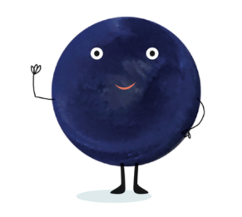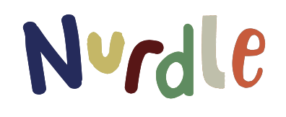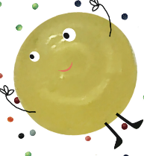

Plastics Debate Sorting Strips

Ensure the children are aware what is meant by the term Plastic and single use plastic.

Give the strips to the children in groups, either pre-cut or they cut them themselves. Ask the children to divide the strips into 3 piles:

Positive about plastic
Against Plastics
In the middle about it.

Sort all of the easy strips and then discuss the ones that are more problematic to place.

Once all of the strips have been sorted, stick them onto the sorting grid and then see if the children can come up with other suggestions.

Debate:
Divide the children into 3 groups and allocate each group one of the three sub headings. They need to look at the comments and add their own and practice their opinions in order to win the debate.

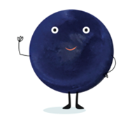
Plastic Debate Sorting Strips
Print onto A3 and insert the strips in the correct columns. Could any be in more than one column?

In favour of plastics | Against plastics | In the middle

Sentences for children to cut up and sort into:
Against plastics, In favour of plastics and in the middle.

Plastics are really important for hospitals to make equipment to keep people safe.
Plastics made all of the PPE and masks that people needed to keep people safe in Covid.
Plastic lasts forever so things last longer.
Plastic is easy to move because it is light, so it saves fuel when being transported.
Plastic is easy to wash and keep clean, so it makes great toys.
Plastic is cheap so it can make lots of things for everybody.
Plastic can be easily moulded into lots of different shapes with moulds and injection moulding, so is very helpful.
Plastic helps to keep food products fresh and hygienic.
Plastic lasts forever, so if it ends up in the sea it takes hundreds of years to break down.
Plastic is so cheap things are made to be thrown away, so people don’t care for things.
Plastic bags are mistaken for jellyfish in the ocean and eaten by turtles.
Plastic bottles can trap animals inside them.
Lots of plastics still can’t be recycled and have to go to landfill.
Masks and PPE can be made of re-usable materials that can be washed and used again, they don’t need to be single use.
Plastic fibres come from clothes when they are washed and end up in the rivers and seas.
If they are handed onto friends and family plastic toys can be as good as wooden toys.
Some companies are giving the money they charge for plastic bags to charity, which can help with the damage they cause.
Plastic face masks are bad, but inhalers help asthmatics.
Plastic fishing nets can kill animals, but for some families in other countries it is their only way of of getting food.
Medical people need plastic PPE, but the rest of people should be using re-usable PPE.
Plastic bottles are good if someone is thirsty and has forgotten their own bottle, but should be recycled.
Some plastics now containing previously recycled plastics in them.

Answers: Sentences for children to cut up and sort into:
Against plastics, In favour of plastics and in the middle.

Plastics are really important for hospitals to make equipment to keep people safe.
Plastics made all of the PPE and masks that people needed to keep people safe in Covid.
Plastic lasts forever so things last longer.
Plastic is easy to move because it is light so it saves fuel when being transported.
Plastic is easy to wash and keep clean so it makes great toys.
Plastic is cheap so it can make lots of things for everybody.
Plastic can be easily moulded into lots of different shapes with moulds and injection moulding, so is very helpful.
Plastic helps to keep food products fresh and hygienic.
Plastic lasts forever, so if it ends up in the sea it takes hundreds of years to break down.
Plastic is so cheap things are made to be thrown away, so people don’t care for things.
Plastic bags are mistaken for jellyfish in the ocean and eaten by turtles.
Plastic bottles can trap animals inside them.
Lots of plastics still can’t be recycled and have to go to landfill.
Masks and PPE can be made of re-usable materials that can be washed and used again, they don’t need to be single use.
Plastic fibres come from clothes when they are washed and end up in the rivers and seas.
If they are handed onto friends and family plastic toys can be as good as wooden toys.
Some companies are giving the money they charge for plastic bags to charity, which can help with the damage they cause.
Plastic face masks are bad, but inhalers help asthmatics.
Plastic fishing nets can kill animals, but for some families in other countries it is their only way of getting food.
Medical people need plastic PPE, but the rest of people should be using re-usable PPE.
Plastic bottles are good if someone is thirsty and has forgotten their own bottle, but should be recycled.
Some plastics now containing previously recycled plastics in them.

