Nurdle Q and A

If you read this information you will become a Nurdle Nerd – Nerdle!

So what is a nurdle?
Nurdles are lentil sized micro-plastics, they are easy to melt and shape and are the pre-production plastics that make all the plastic products in the world.

Are all nurdles white?
No, nurdles can be any colour! Look around your house, any colourful plastic product started life as a nurdle. The most common colours from my experience are white and grey.
The nurdles in my book are all different colours, shapes and sizes, just like humans.

Are all micro-plastics nurdles?
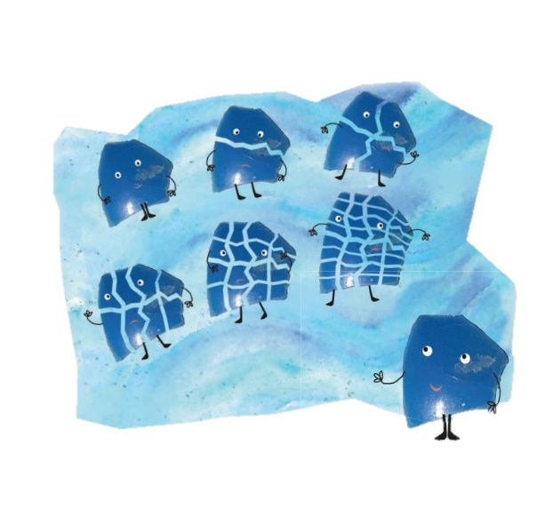
No, a micro-plastic is any plastic less than 5mm, so all nurdles are micro-plastics, but they are primary micro-plastics as they enter the ocean already less than 5mm. However, some micro-plastics are formed when bits wear or break off from larger plastics and these become secondary micro-plastics.

Can one Nurdle be more than one colour?
Yes, I have found many two or even 3 tone nurdles.

Are nurdles all the same size?
No, though they are all tiny, nurdles are all different sizes, widths and thicknesses, but they are all less than 5mm in diameter.
Pre-production nurdles are smooth and rounded, ready to be melted like chocolate.

Know your nurdles
There are some things out there that look like nurdles, but are not part of the nurdle family.
BB gun pellets are larger and more spherical, often brightly coloured.
Polystyrene balls are white and spongy to the touch.
Black or blue ridged, wrinkly looking nurdles are bio beads.

What are bio beads?
Bio beads are are tiny, ridged wrinkled pellets used by many water companies as part of the wastewater treatment process at some of their plants. They are mostly black, but can be blue or white.

How do nurdles end up in the sea?
Nurdles spilt on land at industrial facilities can float off down drains and ultimately, out to sea. Nurdles are lost from damaged bags in transportation. Currents and wind disperse them and they are now washing up on beaches across the globe. Nurdles are also pumped into shipping containers lined with plastic, so if a container is lost overboard and breaks open billions of nurdles can be lost straight into the sea.
Is it safe to collect nurdles?Analysis of nurdles found on beaches show they had adsorbed significant amounts of toxic chemicals including PCBs and DDTs while floating at sea. Collect nurdles using gloves in a jam jar with a lid and wash your hands carefully afterwards.
Can nurdles by recycled?
Currently, nurdles that have been lost and collected cannot be recycled in general recycling. These plastic pieces are the raw material of nearly all our plastic products, which means they are often different types of plastic. Recycling requires different plastics to be sorted, which makes these tiny micro-plastics difficult to recycle.

Are all nurdles bad?
Some plastics are vital and extremely important, and save many lives such as medicines, PPE and hospital machinery. The dangerous plastics are the single use disposable ones.
How are nurdles dangerous?
Nurdles in an ecosystem are often mistaken for food like fish eggs and eaten by animals, so they can be fatal.

Where are nurdles found?
Nurdles can now be found on beaches and in waterways all the way round the world.
See the map on https://www.nurdlehunt.org.uk/nurdle-finds.html

How can you remove nurdles?
Nurdles can be removed from sandy beaches with a nurdle trommel machine. They also float, so add your collected beach debris to water and the nurdles should float off. This doesn’t work on shingle or shale beaches!
www.Nurdle.org has created an ingenious nurdle machine!

How do you remove a nurdle from a shingle beach?
Currently the only efficient way is to painstakingly collect them by hand or to call on the services of Nurdle.org. This was a problem that I set my year 3 class for a national engineering competition and their inventions were genius! From static balloons on a stick, to a remote control nurdle drain sucker to huge nets out at sea. What would you invent?

How can I help?
Look at the Great nurdle hunt website and join them in finding and tracking nurdles. Share the story of Nurdle. Don’t purchase any more single use plastics!!

Why are single use plastics a problem?
Nurdles are made to use all plastic products, so the more plastic we use, the more nurdles are produced, so more escape into the environment and the waterways. Even if they are rescued from the sea the end up in landfill and are so light, they end up back in the cycle of pollution!

CONGRATULATIONS
You are now officially a Nerdle!!

